1. UML for Shopping Cart System:

Below is the Use CaseDiagram (UML) for shopping cart system.

In the below use case diagram, there are two actors named Customer and Admin.

There are a total of Eight use cases that represent the specific functionality of a Shopping Cart system. Each actor interacts with a particular use.

A Customer can check Product List, Product search, Product to cart, Modify product in cart as well as Remove product from cart on the application or a system. This actor can perform only these interactions with the system even though other use cases are remaining in the system.

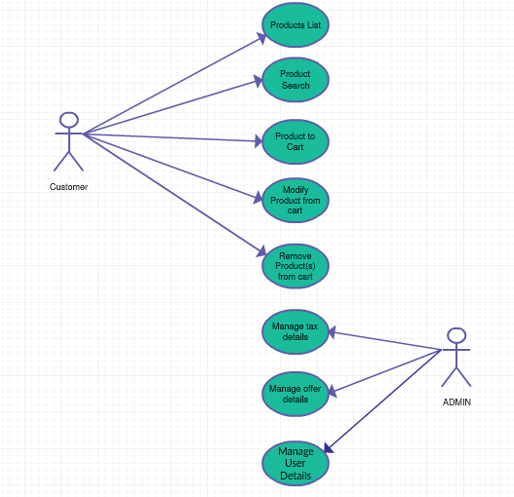

1. Class Diagram(UML) for car inventory

Car inventory class diagram describes the structure sytem class, their attributes, operations and their relationship among objects.

Classes of the car inventory class Diagram:

Accessories – Manages all the operations of car parts

Cars – Manages all the car model and type operations

User – Manages all the User operations

Cart – manages all the purchase operations

Admin – Manages all Inventory operations

Class and their attributes:

Accessories - parts_id, parts_name, parts_types

Cars - car_id, car_name, car_type

User - user_id, password, user_name, email, address, phone_number

Cart - cart_id, product_id, quantity, amount, dest_address, user_id, user_name, email, phone_number

Admin - admin_name, email

